EXPERIMENT 2
EXPLORATORY DATA ANALYSIS (EDA) – DATA IMPORT AND EXPORT
Aim
To import data from various sources such as CSV, Excel, SQL, and Web, perform basic inspection using Pandas, and export the processed data into different file formats.
Algorithm 1: Importing CSV File
Step 1:
Import Pandas library.
Step 2:
Load the CSV file using read_csv().
Step 3:
Display the first few records.
Step 4:
Check the data structure.
Step 5:
Analyze the imported data.
Program 1: Reading CSV File
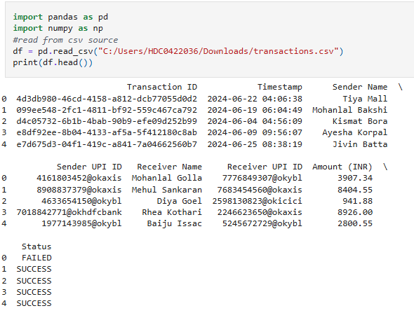
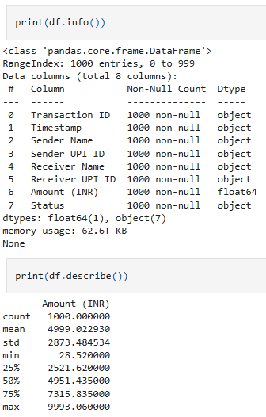
Algorithm 2: Importing Excel File
Step 1:
Create an Excel file.
Step 2:
Use read_excel().
Step 3:
Display the records.
Step 4:
Verify the imported data.

Program 2: Reading Excel File
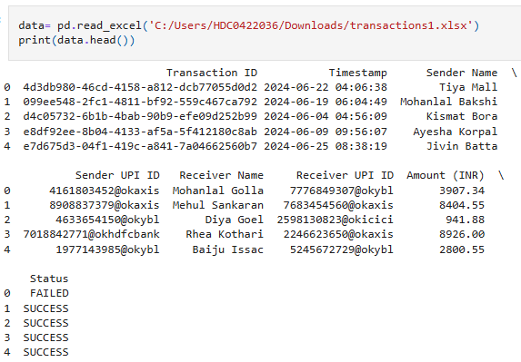

Algorithm 3: Importing SQL Data
Step 1:
Create an SQLite database.
Step 2:
Insert records.
Step 3:
Retrieve records using an SQL query.

Program 3:
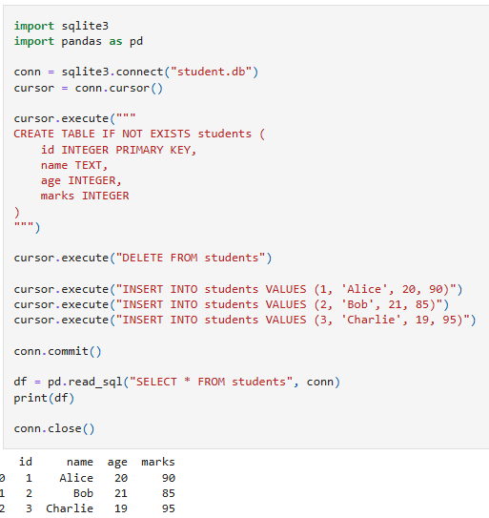
Algorithm 4: Importing Data from Web
Step 1:
Specify the URL.
Step 2:
Load the data using read_csv().
Step 3:
Display the imported records.

Program 4:
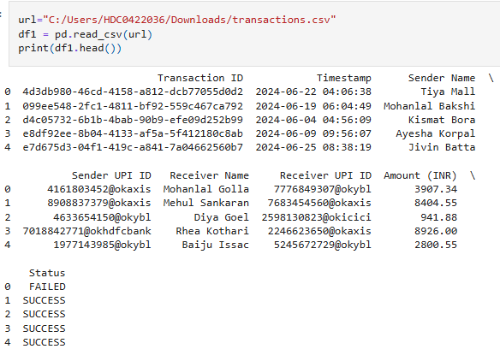

Result
Thus, data was successfully imported from CSV, Excel, SQL, and Web sources using Pandas and exported into different formats such as CSV, Excel, and JSON. The imported data was analyzed and visualized successfully.

